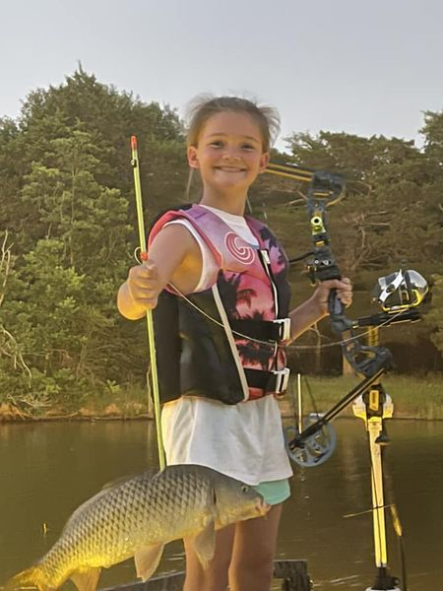  - March-may 2024  bowfishing tournament series  6 lake championship bowfishing tournament  Fish 6 lakes (TBD), accumulate points toward championship, 25% payout to winner of each lake, 50% of entry fees from each of 6 lakes goes to a pot for the winners of the series championship. Must fish 2 of 6 lakes plus final lake to be eligible for championship.  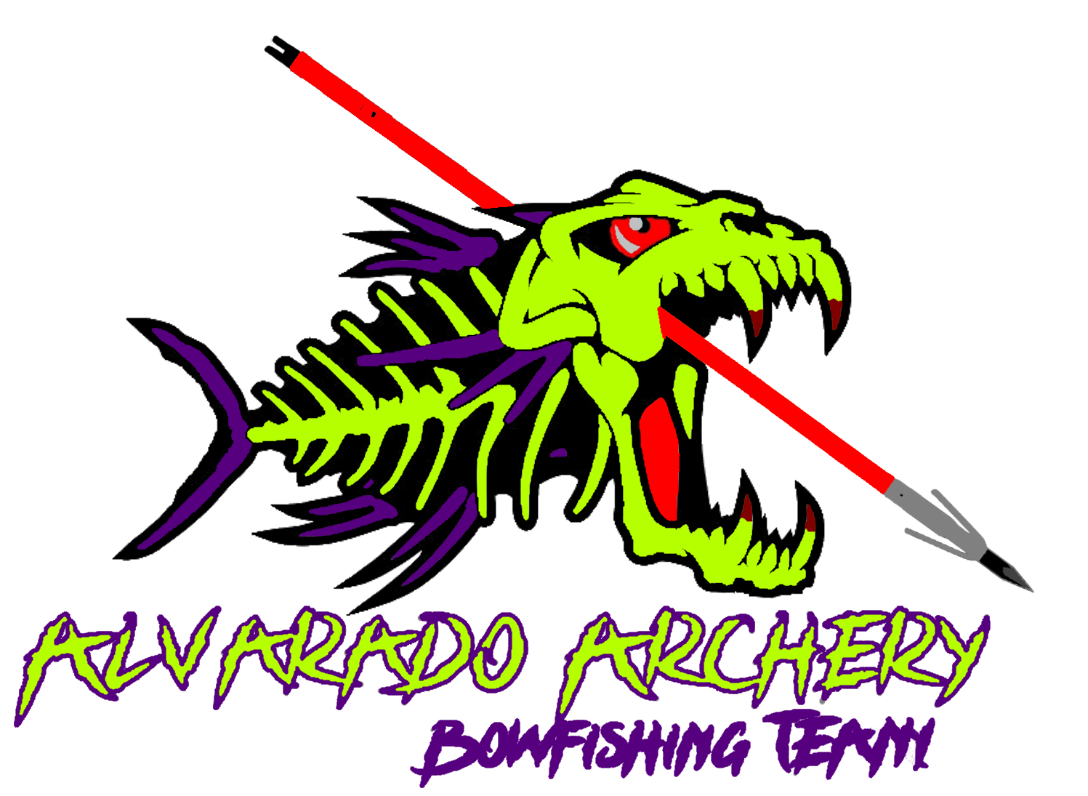 | 6 Lake Tournament Championship Bowfishing Series  ____  March – May $175 entry fee per team  ____  Top 20 Fish Big Fish Pots  Accumulate points each event toward championship  ____  Points leader takes $ of combined pots from 6 events  Alvarado archery  6011 E Hwy 67  Alvarado, Tx 76009  817-783-7300  www.Alvaradoarchery.com  March-May 2024

